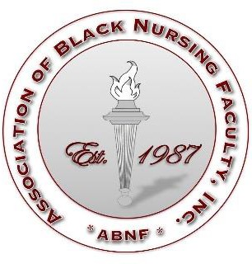
Association of Black Nursing Faculty Research Grant Awards GUIDELINES

PURPOSE
The purpose of the ABNF Small Grant Award is to support and promote the advancement of education research, practice, and nursing science. Funds are available for quantitative and qualitative research on a wide range of topics relevant to nursing. Preference is given to research that is not being conducted for course credit.

ELIGIBILITY
- Current member ABNF when application is received.
- Actively engaged in the profession of nursing.
- Persons who have not received Federal Grant Funding.
- Applicant must be the principal investigator.

GUIDELINES FOR SUBMISSION
Proposals should be submitted electronically. When submitting by e-mail, please include the following information in the subject line of the e-mail: ABNF Small Grant Award Application. All applications must conform to the specifications outlined below.

Application Deadline: March 30th by 11.55 pm CST

FORMAT AND STYLE
- Submit all required documents as one electronic document.
- Use Times New Roman typeface and a font size of 12.
- Double-spaced should be used.
- Number all pages consecutively throughout the application.

COMPONENTS
  - Face Sheet; (Your name, Name of your Institution, Title of your project)
  - Budget (Maximum 2 pages, disclose other sources of confirmed or requested funding).
    - Itemize anticipated expenditure to conduct the project, including supplies and consultants.
    - Indirect costs are not provided.
  - Biographical Sketch
  - Abstract (limit to 250 words – Double-spaced).
  - Project narrative (limit to 5 pages for items 1-5 –Double Spaced)
    - Specific aims and hypotheses/objectives
    - Background and significance
    - Research design and Methods
      - Research Design including setting and subject availability, sample size, recruitment procedure, sample inclusion and exclusion criteria
      - Measures/instruments (as appropriate)
      - Data Collection Procedures (provide rational for procedures used)
      - Data Analysis Plan
    - Timeline
    - Protection of human subjects (include consent forms)
    - Institutional Review Board Approval (IRB) – Funds will not be released until IRB approval is received.
  - Appendices
    - References (limit reference list to 3 pages): Use APA format
    - Include a letter of support from school
    - Research instruments or interview guides (as appropriate)

Please forward your application to: Dr. Kechi Iheduru-Anderson | ihedu1k@cmich.edu

